Semantic Roles

Source: https://people.ischool.berkeley.edu/~dbamman/nlp20_slides/18_semantic_roles.pdf

Semantics
- Lexical: represent meaning of words
- Logical: represent meaning of sentences
- Syntax encodes structure but not directly meaning
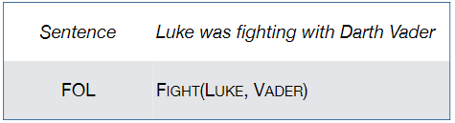
- First-order logic
  - Represent sentence as unambiguous proposition
  - Can specify N-ary relations
- Event semantics
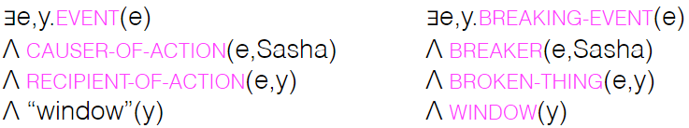
  - Requires comprehensive representation of the world
  - Can weaken relation to shallow semantics
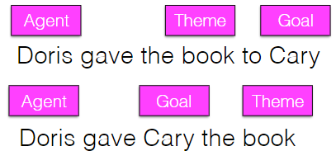
- Thematic role
  - Capture commonality for different relations
  - Can coarsen to proto-roles for generalization
  - Limitation: useful to formally define/too coarse
- Datasets
  - Propbank: argument structure for individual verb senses
  - FrameNet: argument structure for frames (lexical unit)

